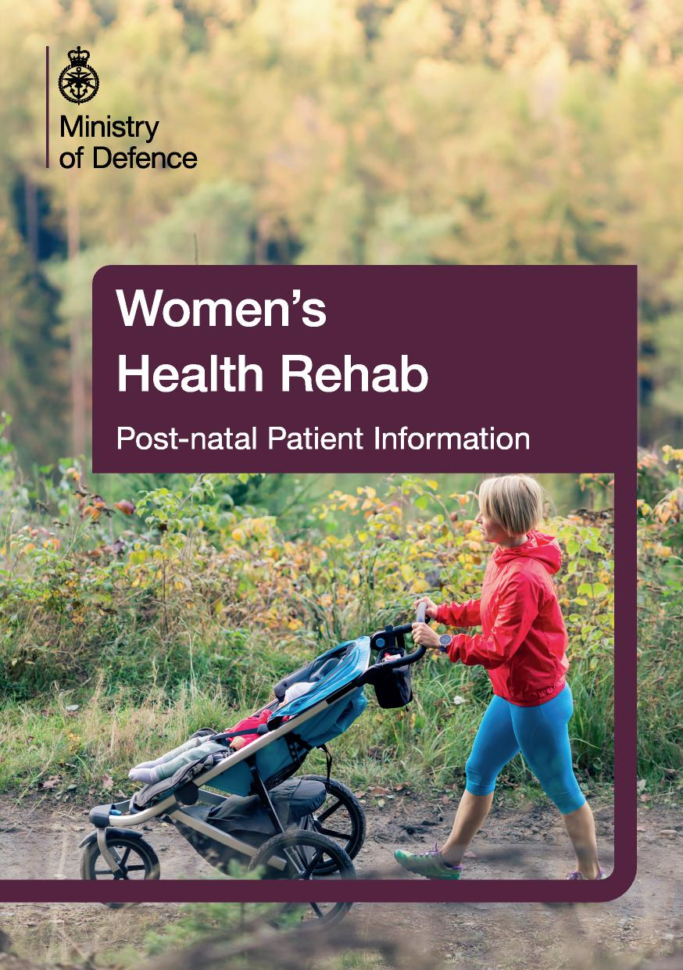

Comfort After Your Delivery
Getting some rest after delivery is important to help your recovery.
Moving Around in Bed
To make moving around in bed more comfortable, here are some simple steps
to follow:
- Avoid large twisting movements (especially if you have had a caesarean delivery). Start with some gentle knee rocks.
- To get out of bed, roll over onto your side and let your legs drop over the edge of the bed, then push yourself up into a sitting position using your arms.
- To get into bed, sit as far on to the bed as you can and lower yourself onto your side using your arms, gently lifting your legs as you go.
Wound Support (for caesarean deliveries)
Coughing, sneezing and laughing may pull on your tummy. To make it more comfortable, try to draw in your tummy muscles, support your wound with a pillow, towel or your hands and apply gentle pressure. Remember to take enough pain relief.
Feeding Your Baby
When feeding your baby ensure that your back and neck are well supported. Support your arms to allow your shoulders and arms to relax. Consider lying positions as well as sting. Speak with your midwife or health visitor if you are struggling.
Breastfeeding and Exercise
- There is no evidence that intense exercise impairs breast milk production.
- Moderate weight reduction while breast feeding is safe and does not compromise baby weight gain.
- Breast feeding women should ensure that their food and fluid intake is adequate to meet their needs. Hydration in particular is important after exercise.
- Breast feeding women may find exercising more comfortable if they have recently breast fed their baby or expressed their milk.
Back Care - advice for life
Your pelvic joints can take months to return to their pre-pregnancy state.
When lifting remember to;
- Bend your knees.
- Tighten your pelvic floor muscles and your deep abdominal muscles.
- Try to breathe out as you lift.
- Keep the object you are lifting in front of, and close to, your body e.g. car seat/ buggy/toddler.
Everyday Activities
It is important to take time to return to normal everyday activities;
- Gradually build up your level of activity and rest between activities.
- Accept help.
- Do not lift anything heavier than your baby for 6 weeks, and avoid lifting anything very heavy for 3 months (for caesarean deliveries).
- Help toddlers to climb (rather than lifting them) or let other people lift them for you.
- Tighten your pelvic floor muscles before lifting your baby.
Diastasis Rectus Abdominis (DRA)
DRA occurs when the two sides of your rectus abdominis muscles separate in pregnancy. This separation is a normal occurrence of pregnancy and in most cases will resolve within 8 weeks. If the muscles do not go back sufficiently you may notice bulging / doming of your tummy with activities such as sitting up in bed or coughing and sneezing. It is important not to overload the recti muscles until the diastasis is resolved. If it has not resolved within 8 weeks you may seek advice from your MO and request a referral to physiotherapy.
Testing for a DRA
Position: Lie on your back, with your knees bent up. Place the four fingertips of
your right hand across ways at the level of your belly button (or where you felt your
diastasis appear).
Action: Curl your head and neck forwards off the floor.
Outcome: Measure how many fingertips will fit into the separation widthways.
Guidelines for abdominal retraining
If you have a diastasis of less than two fingertips wide, you can start gradually strengthening your abdominal muscles. If it is greater than two fingertips wide, do not do sit ups or crunchies. These types of exercises produce excessive tension in the rectus abdominis muscles which may prolong, or worsen, the diastasis you have. You will benefit from the guidance of a physiotherapist who can help coach you through an appropriate exercise programme.
Why is it important to treat?
If you have DRA your abdominal muscles will be weaker. Weak abdominal muscles are linked to problems with back and pelvic pain, poor bowel function and potential problems when returning to fitness.

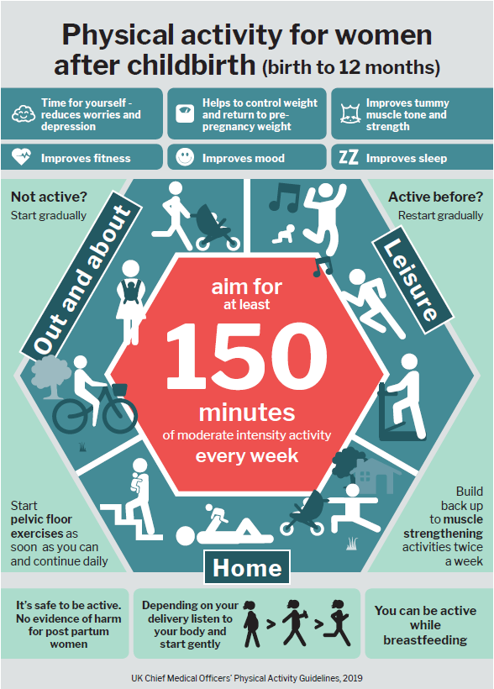
Getting Back to Exercise
The infographic opposite shows some of the benefits of introducing exercise in the post-partum period. Following the advice stated will help you return to exercise in a safe way. Below are further points to consider and some exercise suggestions that would be appropriate to all postnatal women. If you have any concerns then please see your MO who will sign post you to the correct professional for further advice depending on your individual needs.
- Return to exercise gradually.
- Wear a supportive sports bra.
- If you think your breasts may be uncomfortable during exercise, consider breastfeeding/expressing prior to exercise.
- Many women feel extremely tired after childbirth so make sure you pace yourself and get plenty of rest. Accept offers of help!
- Progression to impact activities should not be undertaken too soon, speak to your physiotherapist or PTI if you would like advice on return to fitness after birth.
Cardiovascular exercise
- Brisk Walking - if using a pram ensure the handle is at the correct height so that you do not need to lean forward. If using a carrier ensure the straps are adjusted to avoid neck or back strain. Gradually increase the time and pace of your walks during the first 6 weeks.
- Swimming - this can be commenced once you have had 7 days clear of vaginal bleeding. If you have had a caesarean delivery then wait until you have had your 6-week check.
Activation of your core muscles and strength exercises
- Transversus - lying on your back, gently draw your tummy button down towards your spine. Hold for 15 secs and repeat 10 times. Repeat the same exercise but on all fours.
- Pelvic Tilting - lying on your back with your knees bent feet on the floor. Tilt your pelvis to flatten your back to the floor then slowly tilt in the opposite direction. Repeat 10 times.
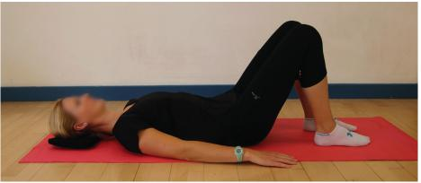
- Shoulder Bridge - starting on your back with the knees bent, pushing through your heels, slowly curl your back off the floor as seen below. Repeat 10 times.
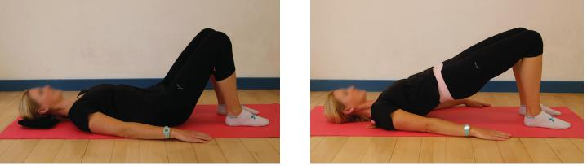
- Knee Rolls - lying on your back with the knees bent, feet on the floor. Keeping the knees together gently drop the knees to the side. Slowly lift them back to the start position before dropping the knees to the opposite side. Repeat 10 times in each direction.
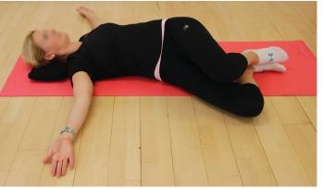
- Happy Cat Angry Cat - on all fours curve your spine starting from the pelvis all the way to the neck. Slowly curve the spine in the opposite direction again. Repeat 10 times.
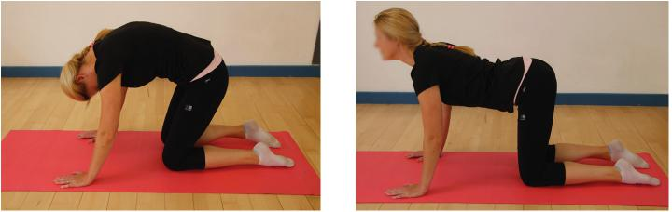
- Thread the Needle - on all fours reach your hand through the opposite arm / leg allowing the spine to rotate. Perform on both sides. Repeat 10 times.
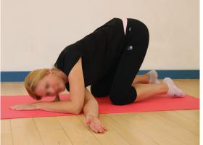
- Child Pose Stretch - from all fours drop the hips backwards to rest on your heels. Stretch the arms out along the floor. Relax in this position for several breaths.
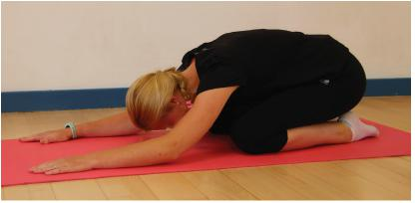
- Sit to Stand from a Chair - start seated in the chair with the feet on the floor hip distance apart. Lean forward with the arms out, push through your feet to standing. Slowly return to sitting aiming to sit as far back in the chair as possible. Try not to use your arms.
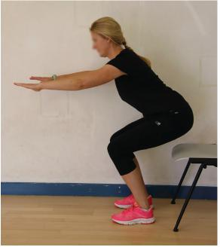
Pelvic Floor Muscle Exercises
Start your pelvic floor exercises as soon as possible after having had your baby (but if you have a urinary catheter wait until it is removed).
- Do the exercises in varying positions.
- Regular tightening and relaxing of the pelvic floor muscles can help to ease discomfort, pain and swelling, and can aid healing if you have had a tear or stitches (using an ice pack on the peroneal area can lessen discomfort).
**Please see separate information leaflet for information and advice, including how to exercise your pelvic floor. Ask your physiotherapist for a copy**
Ask your GP if you have any pelvic girdle pain, urinary or
bowel leakage or uncontrolled loss of wind, sudden vaginal
discomfort, backache or bulging of your abdominal muscles.

Further Information

Pelvic, Obstetric and Gynaecological Physiotherapy (POGP):
www.pogp.csp.org.uk
Royal College of Obstetricians and Gynaecologists: www.rcog.org.uk
Creative Media Design ADR008970

